COAL LAB NO 4
QUESTION 1
- Command
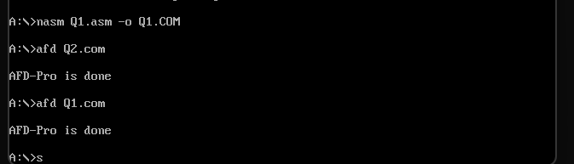
- Code
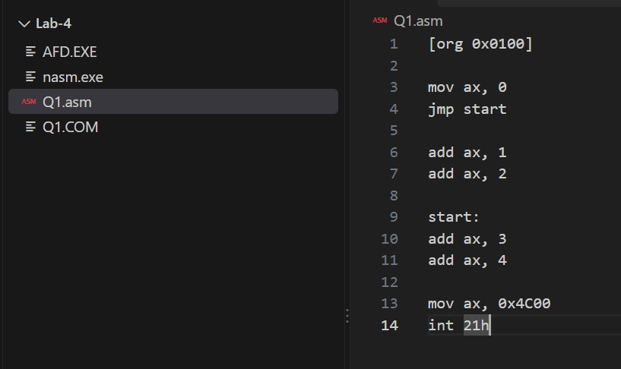
- Before jump
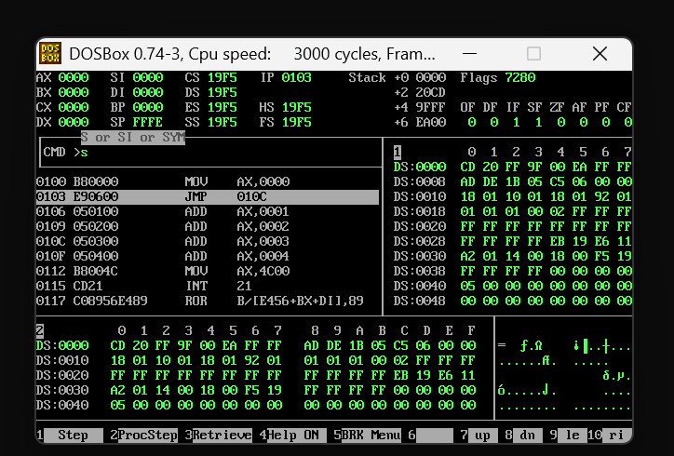

- After Jump (AX 0007)
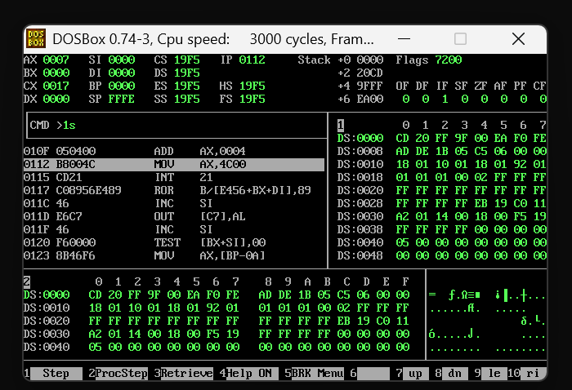

Question2
- Command
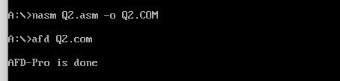
- Code 1
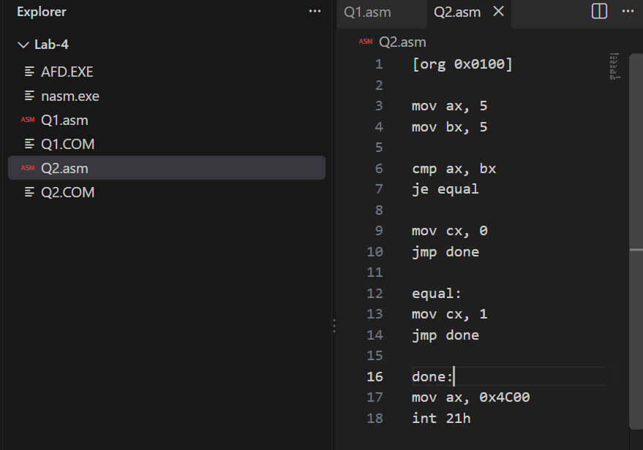
- First camp command run ZF(1)
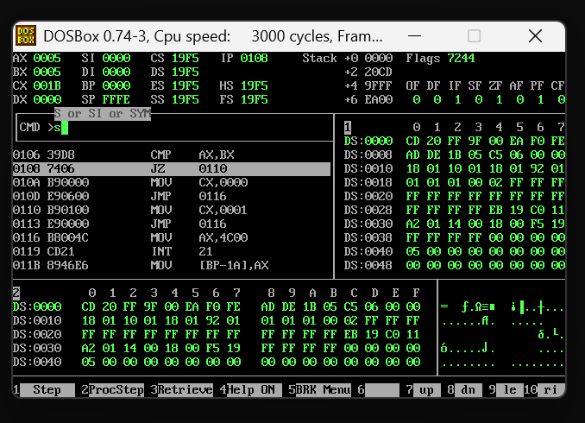
- (CX 1)
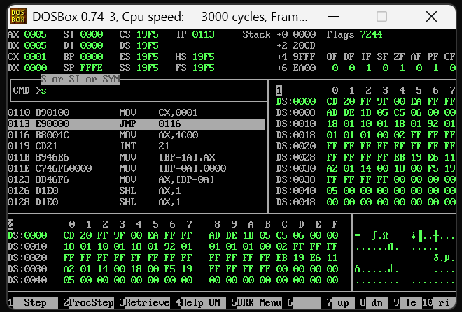
- Code 2
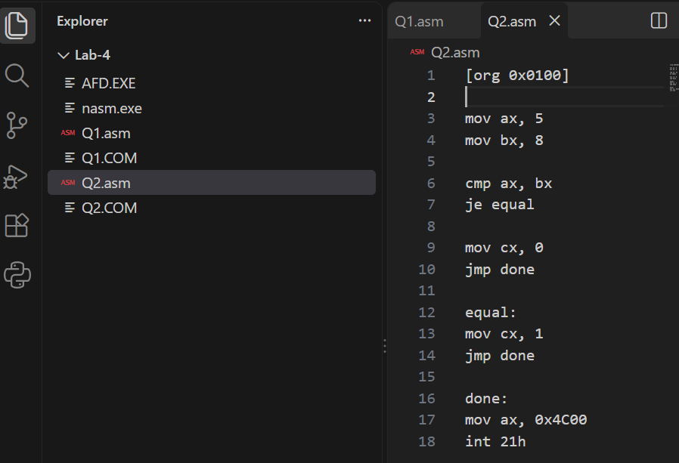

- Second camp command run ZF(0)
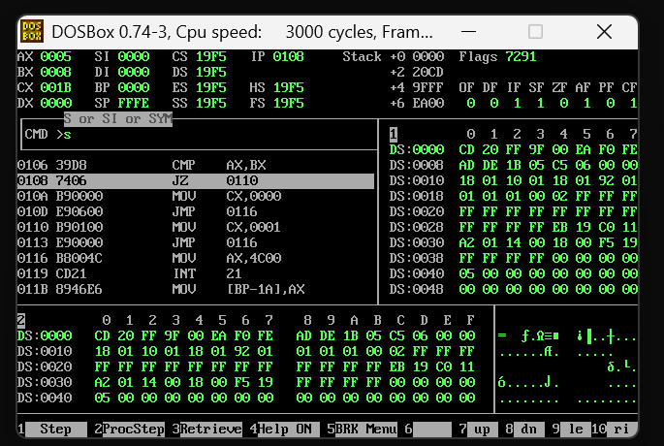

Question 3
- Command
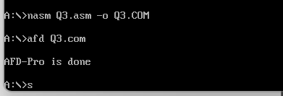
- Code
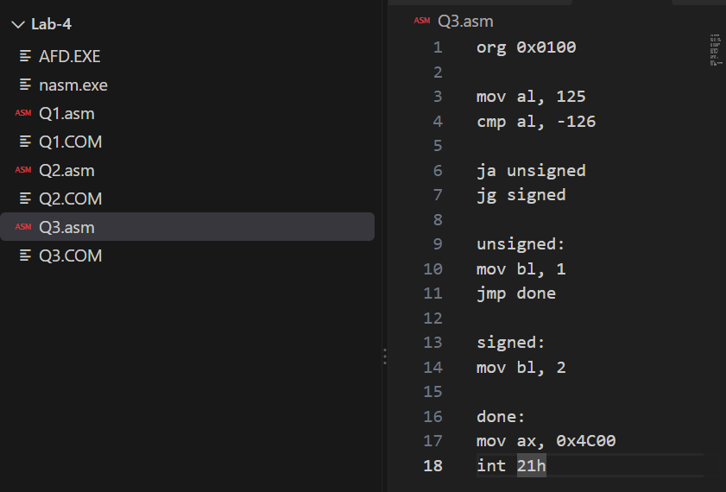
- After comparison flags become
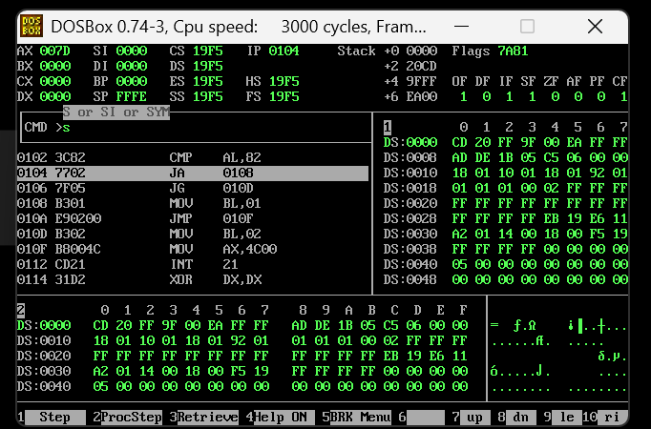
- After JA JB(BX 0002)
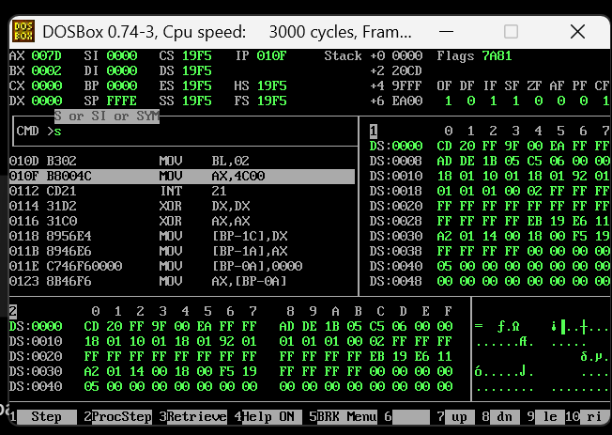
The processor only works with binary values and flags. It does not know whether a value is signed or unsigned.CMP performs the comparison and sets the flags. After that, the jump instruction decides how to interpret those flags:JA → treats values as unsigned ,JG → treats values as signed Therefore, the same CMP instruction and same flags can produce different results depending on whether we use JA or JG.

Question 4
- Command
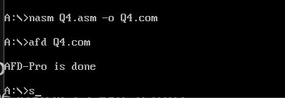
- Code
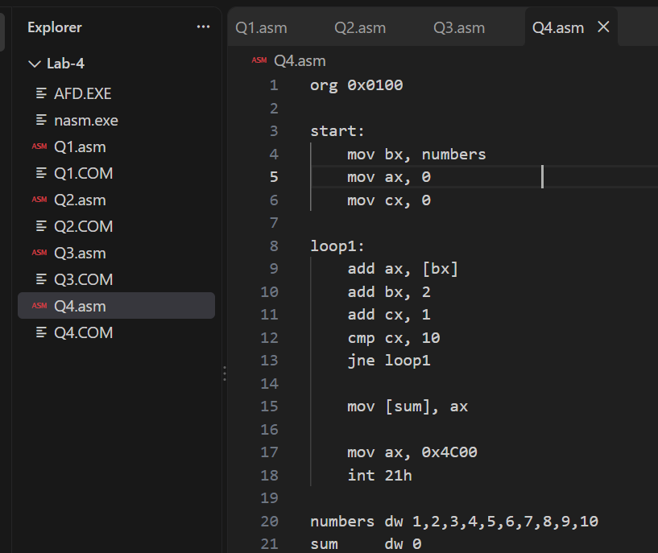
- Partway :After executing some loop cycles
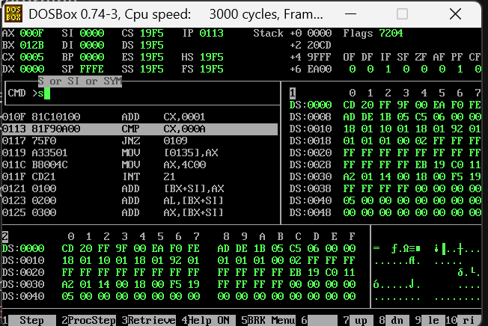
- After ending loop(AX 0037)
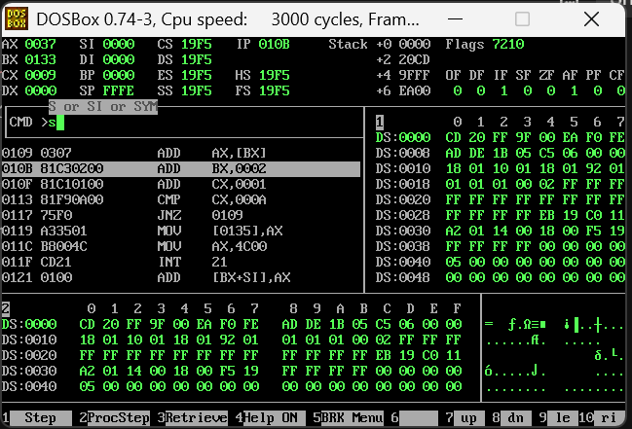
- Note
Last week, we learned direct and indirect addressing. In this program, I used indirect addressing with BX to access the numbers one by one. BX stores the address of the current number, and [BX] gives its value. After adding the value to AX, I increased BX by 2 because each dw value takes 2 bytes. I used CX as a counter and CMP with JNE to repeat the loop until all 10 numbers were processed. Finally, I used direct addressing with mov [sum],ax to store the final answer, 55 (0037h), in memory.

